Assignment 2

# Task 1

Use Google Gemini in Colab to write a Python function that reads  
a list of numbers and calculates the mean, minimum, and  
maximum values

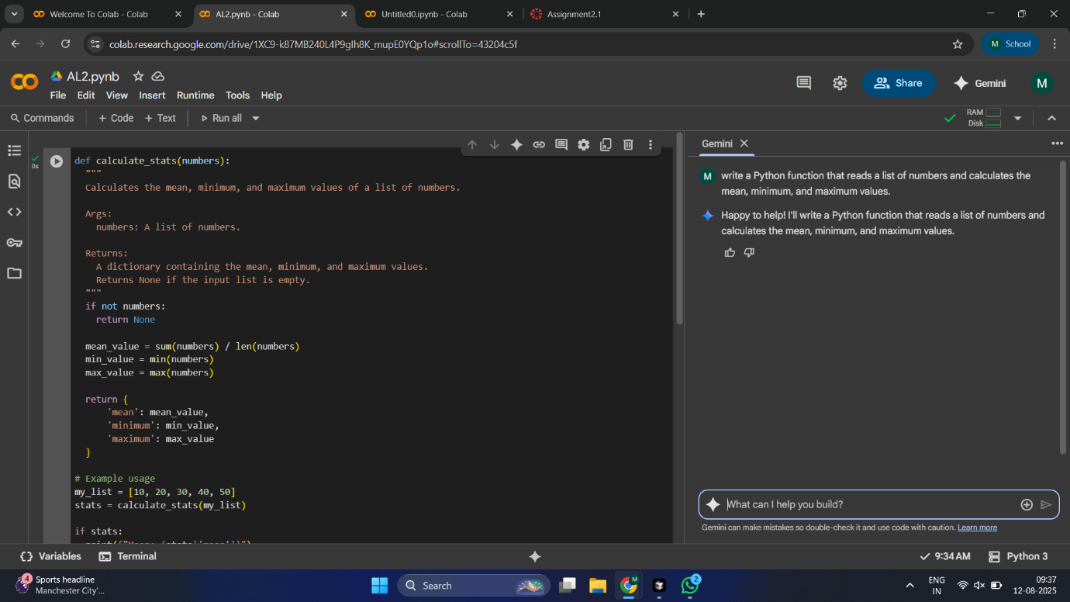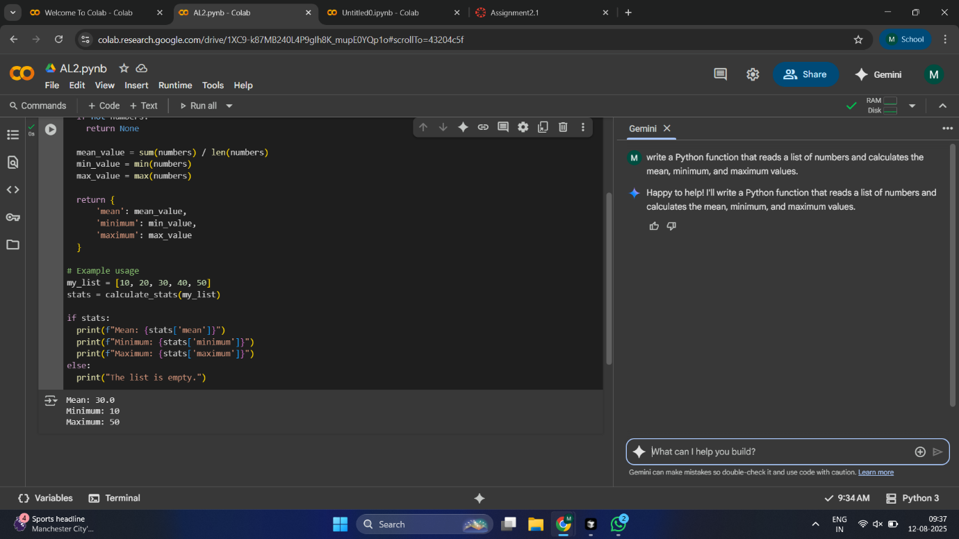

# Task2

Compare Gemini and Copilot outputs for a Python function that  
checks whether a number is an Armstrong number. Document the  
steps, prompts, and outputs

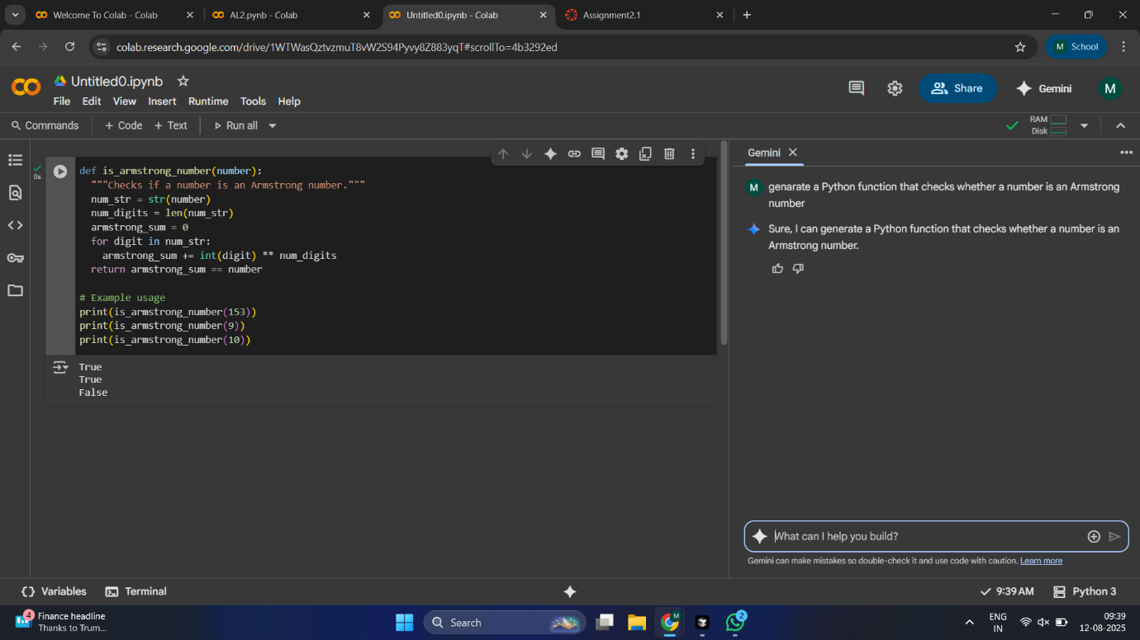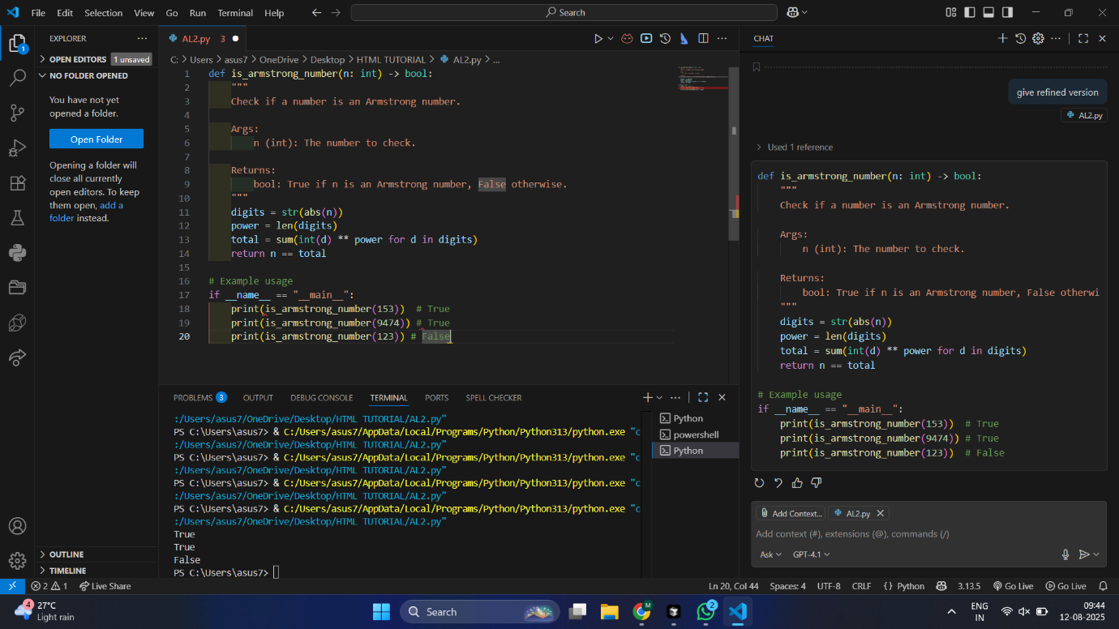

# Task3

Ask Gemini to explain a Python function (e.g., is_prime(n) or  
is_palindrome(s)) line by line.

Choose either a prime-checking or palindrome-checking function  
and document the explanation provided by Gemini

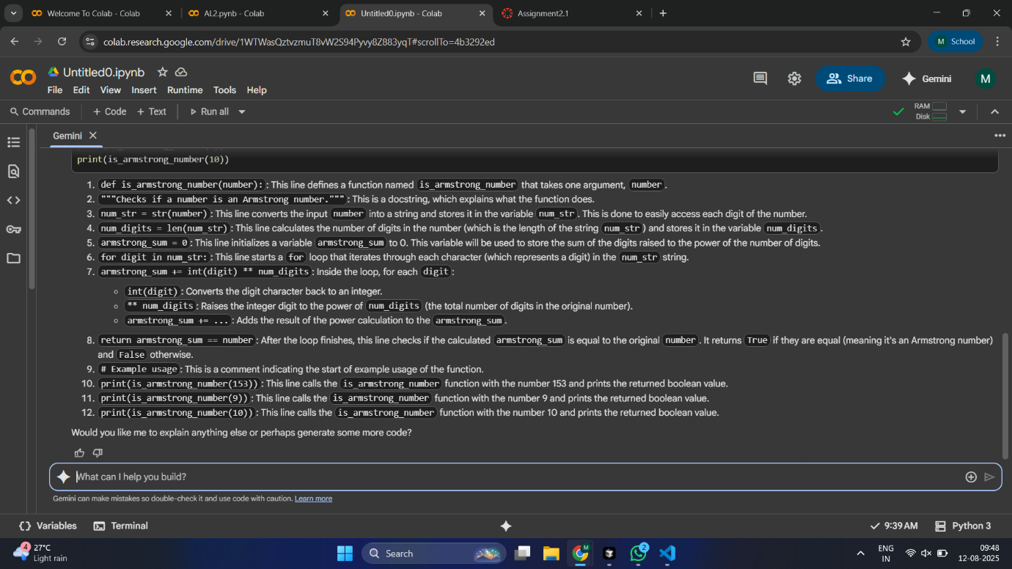

# Task4

Install and configure Cursor AI. Use it to generate a Python  
function (e.g., sum of the first N natural numbers) and test its  
output.

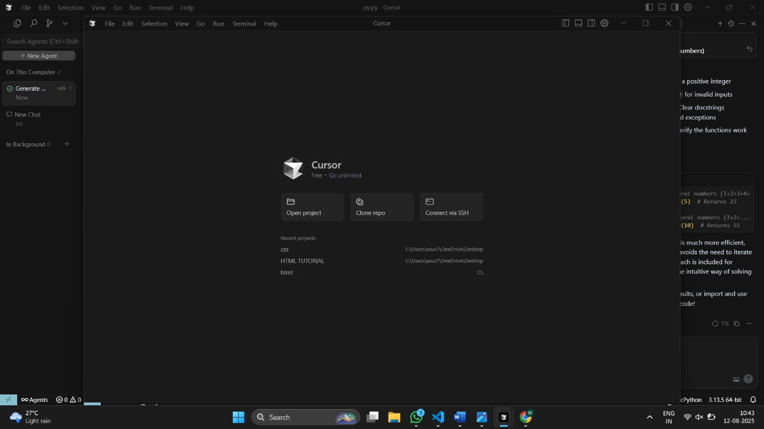

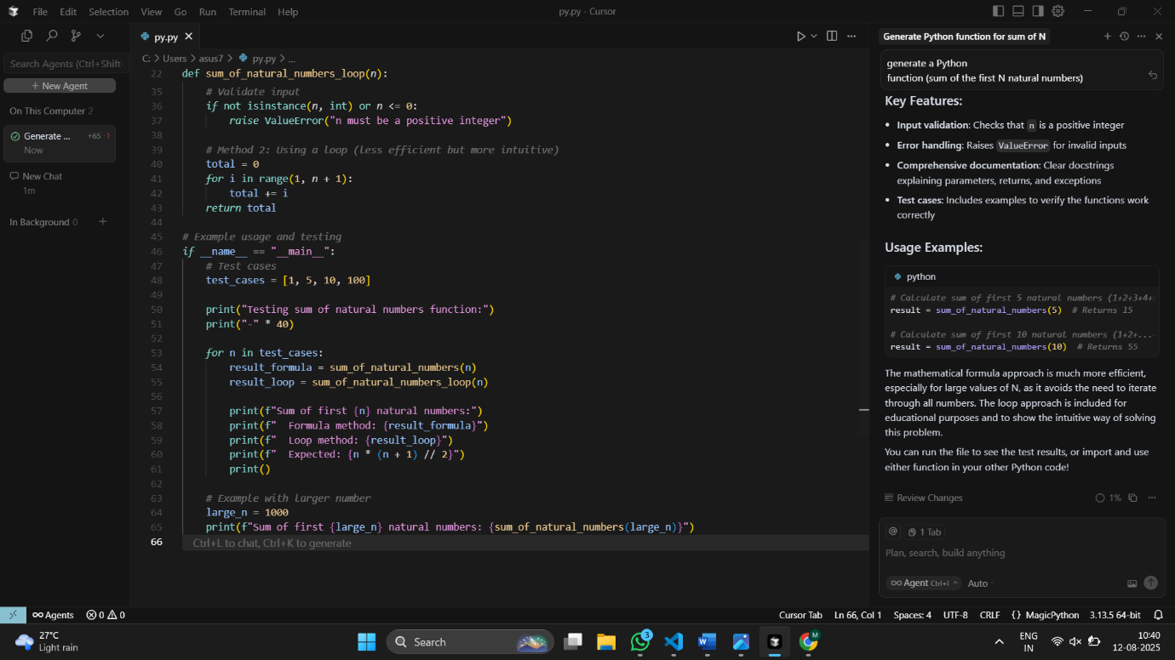

# Task5

Students need to write a Python program to calculate the sum of  
odd numbers and even numbers in a given tuple.

Refactor the code to improve logic and readability

